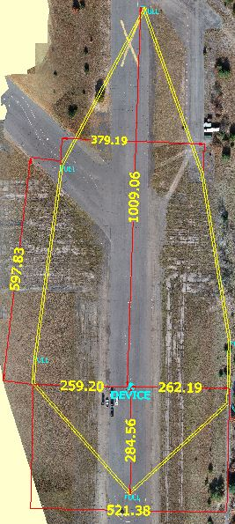
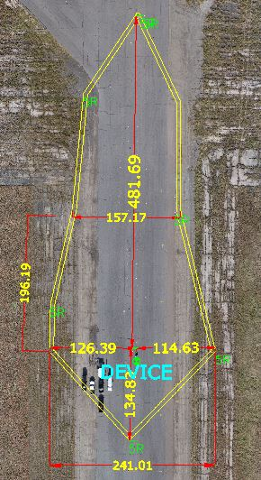FBI EOD – Safe operating dimensions (in Feet) during X-Ray deployment

FULL POWER ACTIVATION – 13R HALF POWER ACTIVATION – 5R

